**WEB-BASED COMPUTERIZED GUIDANCE RECORDS MANAGEMENT SYSTEM**

Capstone Project Presented to

CEDAR College, Inc.

National Highway

Cadiz City, Negros Occidental

In Partial Fulfillment of the

Requirements for the Degree of

Bachelor of Science in Information Technology

Anilo C. Abong

Charls Patrick R. Baquero

Jed C. Magbanua

September 2024

**CHAPTER I**

**INTRODUCTION**

**Project Context**

The Web-based Computerized Guidance Records Management System is designed to address the challenges faced by educational institutions in managing and maintaining student guidance records. In many schools, the traditional method of handling these records is paper-based, which can lead to inefficiencies, data loss, and difficulty in accessing information when needed. This project seeks to provide a modern solution by developing a web-based system that ensures secure, organized, and easily accessible records for guidance counselors and school administrators. By automating key processes such as record tracking, updating, and reporting, the system aims to enhance the effectiveness of student guidance services while ensuring data accuracy and privacy compliance.

**Project Description**

It is a digital platform designed to streamline the management of student guidance records within educational institutions. The system enables guidance counselors and administrative staff to securely store, retrieve, and update student information, including counseling history, academic performance, and behavioral records. With a user-friendly web interface, the system facilitates easy access to records from any location, providing real-time updates and generating detailed reports. The project aims to improve data organization, reduce paperwork, enhance collaboration among staff, and ensure compliance with data privacy regulations, ultimately fostering more efficient and effective student support services.

**Objectives**

The main objective of the "Web-based Computerized Guidance Records Management System" is to streamline the management of student guidance records through a secure and accessible web-based platform. Furthermore, the specific objectives are as follows:

1. To allow guidance counselors and administrators to easily store, update, and access student guidance records in real-time, ensuring an organized and efficient record-keeping process;
2. To facilitate the generation of comprehensive reports, helping staff monitor student progress and make informed decisions based on accurate data; and
3. To ensure the security and confidentiality of sensitive student information, providing a reliable and user-friendly system that improves overall institutional efficiency.

**Scope and Limitation**

A web-based computerized records management system is designed to streamline the storage, retrieval, and management of digital records, providing users with easy access and efficient organization of data. The system offers real-time accessibility, centralized storage, and enhanced data security, reducing the reliance on paper-based records and minimizing the risk of data loss.

However, the system's limitations include potential security vulnerabilities due to internet connectivity, reliance on consistent network access, and the possibility of unauthorized access or data breaches if not properly secured. Additionally, there may be challenges related to user adoption and training.

**Definition of Terms**

1. **Guidance records**

A structured documents and data related to the counseling and advising services provided to students, encompassing academic performance, session notes, and career guidance. In a CGRMS, these records are stored digitally with specific fields for student IDs, session dates, and counselor notes, allowing authorized users to access and update the information efficiently. Operationally, guidance records are maintained in a digital format within a CGRMS, featuring structured fields for essential information, ensuring secure and efficient access for authorized personnel.

1. **Database management**

The systematic organization, storage, and retrieval of data within a database system, ensuring data integrity, security, and efficient access. Operationally, in a Course Guidance and Career Selection Record Management System (CGRMS), this is managed through a relational database management system (RDBMS) that creates and maintains tables for guidance records while implementing data consistency and backup procedures.

1. **User authentication**

The process of verifying a user's identity to ensure that only authorized individuals can access and manipulate sensitive data. Operationally, in a Course Guidance and Career Selection Record Management System (CGRMS), this involves login procedures that require usernames and passwords for access.

1. **Record retrieval**

The process of accessing specific information from a database or record-keeping system based on user queries or criteria. Operationally, this involves search functionalities that enable users to query the database by parameters such as student ID or session date, resulting in the display of relevant records.

1. **User Access Control**

Manages permissions and access rights for different users within a system to ensure individuals can only access data and functions appropriate to their roles. Operationally, this is often implemented through role-based access controls (RBAC), assigning users specific roles, such as counselor or administrator, and granting them permissions based on those roles to access necessary records and features.

1. **User Interface (UI)**

The point of interaction between users and a software system, encompassing all elements such as buttons, forms, and menus. Operationally, the UI is designed to be user-friendly and intuitive, facilitating easy navigation, record entry and retrieval, and other tasks through effective layout design, navigation elements, and interactive features.

1. **System Maintenance**

Refers to the ongoing process of keeping a software system operational and up-to-date by fixing bugs, applying updates, and optimizing performance. Operationally, this includes routine tasks such as applying software patches, updating the system for new features, and performing performance tuning to ensure reliability and security.

1. **User Training and Support**

Involve educating users to help them effectively utilize a system and address any issues that arise. Operationally, this may include offering training sessions, user manuals, and a helpdesk for troubleshooting, ensuring users become proficient and can access assistance when needed.

1. **Data Security**

Refers to the protection of information from unauthorized access, use, disclosure, disruption, modification, or destruction. Operationally, this includes measures implemented in the CGRMS to safeguard student data, such as encryption, access controls, and backup procedures.

1. **System**

A system is a set of interrelated components that work together to achieve a common goal. Operationally, it consists of hardware, software, data, and procedures designed to efficiently and effectively manage guidance and counseling records.

**Review of Related Literatures**

According to Alenezi and Al-Harbi (2019), the development of a guidance and counseling record management system addresses inefficiencies in traditional paper-based methods, which are often prone to errors, mismanagement, and difficulties in retrieving necessary information promptly. Their proposed computerized system facilitates the storage and retrieval of records, offering real-time access to students' counseling data while prioritizing user-friendliness to ensure school counselors can easily input and track student information with secure authentication processes to maintain data privacy. The system enhances the overall efficiency of counseling services by reducing administrative burdens, improving accessibility, and ensuring that records are well-organized and easily searchable, leading to more effective decision-making in student guidance. However, the authors acknowledge challenges such as the initial financial costs of implementing the system and the need for user training in the digital environment. Despite these limitations, they argue that the long-term benefits of accuracy, security, and efficiency make computerized records management systems essential tools for modern educational institutions.

According to Mahir et al. (2021), the online Vocational Guidance Management System (VGMS) was designed specifically for vocational high schools to address the growing need for more efficient and accessible guidance systems. The study highlights the challenges vocational schools face in managing student guidance data, often leading to delays and inefficiencies in career counseling services. By transitioning to an online platform, the VGMS provides real-time data management, offering easy access to records, progress tracking, and career planning tools for both students and counselors, optimizing the guidance process while reducing counselors' workload and improving service quality. The system supports better decision-making through data-driven insights that tailor guidance programs to individual student needs, integrating modules such as student profiles, counseling records, and career path recommendations for a holistic approach to vocational guidance. Despite its benefits in streamlining operations, the authors acknowledge challenges, including the need for reliable internet access and user training. Nonetheless, the VGMS is considered a valuable tool for enhancing the quality and efficiency of vocational guidance services in educational institutions.

According to Alyateem (2021), a general framework for applying knowledge management principles to student guidance in general education within the Kingdom of Saudi Arabia is crucial for improving the quality of guidance services. The study emphasizes the effective organization and management of knowledge, allowing educators and counselors to access relevant student data, past guidance records, and educational resources in real-time, which facilitates more informed decision-making. The framework encourages collaboration between counselors, teachers, and administrators to ensure student guidance is holistic and aligned with educational goals. Key components of the framework include data collection, storage, and analysis, contributing to a more structured and consistent approach to student counseling across institutions. While the study acknowledges challenges such as the need for technological infrastructure and staff training to use knowledge management tools effectively, it positions the framework as a critical step toward modernizing student guidance services in Saudi Arabia's general education system.

According to Wamalwa (2021), guidance and counseling play a crucial role in managing student discipline in tertiary colleges within the Western Region of Kenya by improving student behavior and reducing indiscipline. The study highlights that effective counseling programs equip students with essential life skills, emotional support, and behavioral guidance, helping them navigate academic and social challenges more effectively. Well-implemented counseling services foster a positive learning environment, allowing students to make better decisions and maintain discipline. Wamalwa also emphasizes the need for trained counselors to provide individualized attention and professional advice to students facing personal or academic issues that may lead to misconduct. However, challenges such as inadequate resources, lack of counselor training, and a low counselor-to-student ratio can hinder the effectiveness of these programs. Despite these limitations, the study concludes that a strong guidance and counseling framework is essential for managing discipline, improving student behavior, and ultimately enhancing academic performance and personal growth.

According to Sharma and Kumar (2019), a comprehensive study on the effectiveness of guidance and counseling services in higher education institutions evaluates their impact on student academic performance and overall well-being. The authors emphasize that these services are crucial for helping students navigate challenges such as academic stress, career planning, and personal development. Through surveys and interviews with students and counselors, the study identifies key factors contributing to the effectiveness of these services, including the availability of trained counselors, the relevance of counseling programs, and resource accessibility. The findings indicate that effective guidance and counseling can lead to improved student outcomes, increased satisfaction, and better retention rates. Additionally, Sharma and Kumar discuss challenges faced by higher education institutions, such as inadequate funding, a shortage of trained personnel, and limited student awareness of available services. They advocate for strengthening counseling frameworks by investing in professional development for counselors, enhancing outreach efforts to raise student awareness, and integrating counseling services into the overall academic experience. Ultimately, the study concludes that addressing these challenges and optimizing guidance and counseling services can significantly contribute to the holistic development of students.

According to Malaluan (2023), the investigation of life values among college students at a state university in the Philippines serves as a foundational study for developing a proposed guidance and counseling program. The research identifies key values prioritized by students, such as integrity, respect, and responsibility, which are essential for their personal development and academic success. By assessing these values, Malaluan aims to provide insights that inform the design of counseling interventions tailored to the unique needs and challenges faced by students. The study emphasizes the importance of understanding students' values to foster an environment conducive to their growth and well-being. Additionally, Malaluan discusses the implications of these findings for creating a comprehensive guidance and counseling program that incorporates the identified life values into its framework, promoting character development and ethical decision-making. The research highlights the need for effective counseling strategies that resonate with students' values and aspirations, ultimately enhancing their educational experience. While acknowledging potential challenges in program implementation, such as resource limitations and varying student backgrounds, the study argues that a value-centered approach can significantly improve the overall effectiveness of guidance and counseling services at the university.

According to Alegado, R., Alegado, A., and Alcantara (2021), a comprehensive study on the development of a Guidance and Counseling Record Management System aims to improve the management of student counseling records in educational institutions by addressing the inefficiencies of traditional record-keeping methods, which often lead to lost or mismanaged student data that hinders counselors' ability to provide effective support. The proposed system leverages technology to create a centralized database, allowing counselors to easily input, retrieve, and manage student records securely. By facilitating better organization and access to information, the system enhances the overall efficiency of counseling services and promotes a more proactive approach to student guidance. Furthermore, the study outlines key features of the system, including user authentication, data encryption, and reporting capabilities, which ensure the confidentiality and integrity of sensitive student information. Alegado et al. emphasize that implementing such a system not only improves record accuracy but also empowers counselors to make data-driven decisions regarding student support interventions. While acknowledging potential challenges, such as the need for staff training and technical infrastructure, the authors argue that the benefits of a well-implemented Guidance and Counseling Record Management System are substantial, positioning it as a vital resource for educational institutions seeking to enhance their counseling services and better serve their students.

According to Alonzo (2019) discusses the development and implementation of a real-time decision support system tailored for guidance and counseling services. The system was designed to assist counselors and educational institutions in making data-driven decisions to enhance student outcomes. By integrating real-time data analytics, the platform enables users to assess academic performance, track behavioral patterns, and provide immediate interventions. The study emphasizes the role of technology in transforming traditional counseling methods, highlighting the importance of timely feedback and personalized recommendations in addressing the diverse needs of students. The research also explores the challenges in adopting such systems, including data security, system scalability, and the need for training counselors to effectively utilize the technology. Alonzo (2019) concludes that while the real-time guidance and counseling decision support system demonstrates significant potential to improve service delivery, its success depends on institutional support, adequate funding, and continuous system updates. The study contributes to the growing body of literature on integrating technology in educational counseling and underscores the need for further research to optimize these tools for various educational settings.

According to Dalangin et al. (2022) present ChatTalkCGC, a responsive platform designed to facilitate guidance and counseling for both academic and non-academic concerns at Malayan Colleges Mindanao (MCM). The platform incorporates advanced features such as real-time chat support, automated appointment scheduling, and a user-friendly interface to streamline communication between students and counselors. By focusing on accessibility and responsiveness, the system aims to address common barriers in traditional counseling methods, such as delays in communication and limited counselor availability. The authors emphasize that ChatTalkCGC offers a holistic approach to student support, enabling counselors to provide timely and personalized

interventions. The study also highlights the technical and operational challenges encountered during the platform’s development, including maintaining data privacy, ensuring system scalability, and integrating the platform into the institution's existing infrastructure. Dalangin et al. (2022) underscore the importance of user feedback in refining the system and ensuring its adaptability to evolving student needs. Their findings demonstrate the potential of digital platforms like ChatTalkCGC to enhance the overall counseling experience while promoting student well-being. This research contributes to the ongoing discourse on leveraging technology for improved educational services and sets a foundation for further innovations in student support systems.

According to Agustin and Babaran Jr. (2021) explored the development of a Guidance Records Management System (GRMS) designed to streamline the management of student records in educational institutions. The system integrates SMS notifications to keep students informed about their academic progress, appointments, and other important events. By incorporating this technology, the system aims to enhance communication between students and guidance counselors, ensuring timely updates and fostering a more efficient interaction. The authors argue that such a system can improve the administrative efficiency of guidance services and reduce the manual workload associated with record-keeping. The study emphasizes the need for educational institutions to adopt more advanced digital tools in managing student records. It highlights the importance of accessibility and real-time updates, which are facilitated by the SMS notification feature in their proposed system. on the separate study the integration of this communication tool not only enhances the students' experience by providing immediate feedback but also helps counselors manage their caseload more effectively. The system, therefore, represents a significant step toward modernizing guidance services and making them more responsive to student needs.

**REFERENCES**

Alenezi, A. M., & Al-Harbi, M. M. (2019)*. Design and implementation of a guidance and counseling record management system.* International Journal of Advanced Computer Science and Applications, 10(4), 72-80.

Retrieved from: <https://doi.org/10.14569/IJACSA.2019.0100409>.

Date Accessed: September 8, 2024.

Mahir, A., et al. (2021). *The online model of the Vocational Guidance Management System (VGMS) for vocational high school.* IOP Conference Series: Materials Science and Engineering, 1098, 052094.

Retrieved from: https://doi.org/10.1088/1757-899X/1098/5/052094.

Date Accessed: September 14, 2024.

Alyateem, A. (2021). *General framework to apply knowledge management to student guidance in general education in the Kingdom of Saudi Arabia.*

Retrieved from: <https://www_researchgate.net/profile/AbdullahAlyateem/>

publication/351409564.

Date Accessed: September 15, 2024.

Wamalwa, E. B. (2021). *Role of guidance and counselling in managing discipline among tertiary college students in Western Region, Kenya.*

Retrieved from: <https://41.89.96.81:8080/xmlui/handle/123456789/1958>.

Date Accessed: September 16, 2024.

Sharma, R., & Kumar, A. (2019). *A study on the effectiveness of the guidance and counseling services in higher education institutions.* International Journal of Advance Research in Management, Social Sciences & Humanities, 7(6), 45-55.

Retrieved from: https://garph.co.uk/IJARMSS/June2019/G-2639.

Date Accessed: September 9, 2024.

Malaluan, D. J. U. (2023). *Life values of college students of a state university in the Philippines: Baseline for a proposed guidance and counseling program.* European Journal of Natural and Social Sciences, 8(1), 15-26.

Retrieved from: https://european-science.com/eojnss_proc/article/view/6417/2908.

Date Accessed: September 14, 2024.

Alegado, R., Alegado, A., & Alcantara, G. (2021). *Guidance and Counseling Record and*

*Management System.* International Journal of Advanced Trends in Computer Science Engineering,

10(3), 2138–2144.

Retrieved from: <https://doi.org/10.30534/ijatcse/2021/891032021>.

Date Accessed: September 9, 2024.

Alonzo, A. B. (2019*). Real-time guidance and counseling decision support system. International*

*Journal of Advanced Research in Management and Social Sciences, 8(6), 361-394.*

Retrieved from: https://garph.co.uk/IJARMSS/June2019/G-2639.

Date Accessed: November 20, 2024

Dalangin, R. L. L., Dubouzet, A. A. M., Ferrazini, M. A. D. T., Llido, J. A. S., & Cerna, P. D.

(2022, October). *ChatTalkCGC: A responsive platform for guidance and counselling of academic*

*and non-academic matters in MCM. In AIP Conference Proceedings (Vol. 2502, No. 1). AIP*

*Publishing.*

Retrieved from: <https://doi.org/10.1063/5.0108485>

Date Accessed: November 20,2024.

Agustin, J., & Babaran Jr, C. (2021). *Guidance Records Management System with SMS*

*Notification. Linker: The Journal of Computing and Technology, 2(1).*

Retrievedfrom: https://isujournals.ph/oldlinkerjournalsfiles/TJCT.isujournals.ph/index.php/tjct/article/view/14

Date Accessed: November 20, 2024

**CHAPTER II**

**Research Method**

The researcher employed a descriptive qualitative research method by conducting semi-structured interviews to gather insights from guidance counselors, administrative staff, and other stakeholders involved in managing student guidance records. This approach allowed participants to share their experiences, challenges, and needs in transitioning from manual or outdated systems to a computerized solution. By focusing on understanding these workflows and pain points, the researcher identified key themes and patterns to inform the system’s design, ensuring it addressed actual operational requirements. This method was descriptive, as it aimed to document and explore participants’ perspectives without attempting to manipulate or test variables, making it well-suited for capturing the practical needs and expectations of the target users.

**Locale of the Study**

The study was conducted at Cedar College Inc., located in National High way Cadiz City, Negros Occidental, Philippines. This institution provided an ideal setting to assess challenges in managing student guidance records and to test the Web-Based Computerized Guidance Records Management System, aimed at improving efficiency and data management processes.



**Theoretical Framework**

**Waterfall Model**

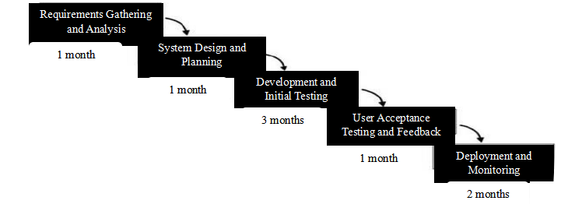

The "Web-Based Computerized Guidance Records Management System" employs the Waterfall model because it provides a structured, sequential approach to development, making it ideal for a project with clearly defined requirements and fixed timelines. The Waterfall model allows the team to thoroughly plan and design each phase before moving on to the next, ensuring a clear and predictable development process. This approach is particularly beneficial for the system, as the requirements for guidance record management are well understood and less likely to change during the development cycle. By following a systematic process of design, development, and testing, the Waterfall model ensures that the system meets all operational and regulatory requirements, providing a stable and reliable solution for managing student guidance records.

**Use Case Diagram**

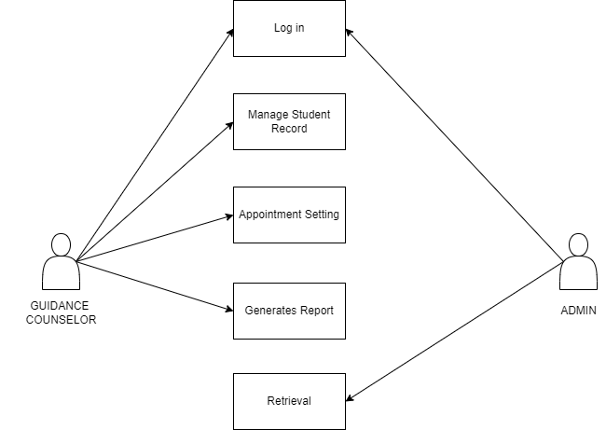

**Requirements Cost**

|  |  |  |
| --- | --- | --- |
| **Description** | **(Admin)** | **(User)** |
|  |  |  |
| **I. HARDWARE REQUIREMENTS** |  |  |
| * Server Computer(x1) | ₱100,000 |  |
| * Client Workstations (x2) |  | ₱25,000 |
| * NAS Storage Device (10TB - 20TB) | ₱30,000 |  |
| * Backup System | ₱10,000 |  |
| * Peripherals (Printers, Scanners, UPS units) | ₱30,000 |  |
|  |  |  |
| **II. SOFTWARE REQUIREMENTS** |  |  |
| * Operating System (Server OS) | ₱30,000 |  |
| * Database Management System | ₱0 |  |
| * Application Software | ₱150,000 |  |
| * Web Server Software | ₱0 |  |
| * Security Software (Antivirus, Firewalls) | ₱10,000 |  |
|  |  |  |
| **III. NETWORK REQUIREMENTS** |  |  |
| * 300 Mbps Fiber Plan (annual) | ₱25,000 |  |
| * Cisco Gigabit Router | ₱5,000 |  |
| * Network Switch (8-port) | ₱3,000 |  |
| * VPN Setup | ₱5,000 |  |
| * Network Monitoring Tools | ₱0 |  |
|  |  |  |
| **IV. INTEGRATION REQUIREMENTS** |  |  |
| * System Integration Services | ₱30,000 |  |
| * Testing and Validation | ₱10,000 |  |
| * Training for staff | ₱5000 |  |
| * Support and Maintenance (annual) | ₱20,000 |  |
|  |  |  |
| **TOTAL COST:** | ₱463,000 | ₱25,000 |

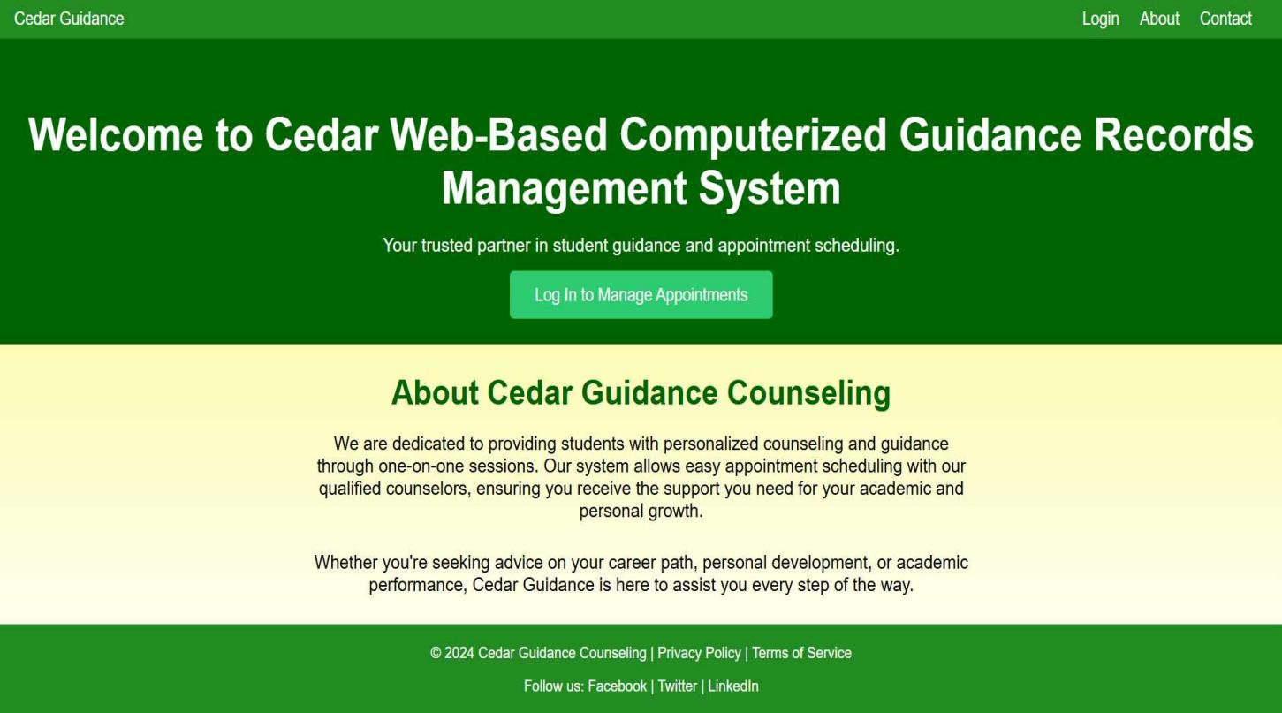**System Prototype**

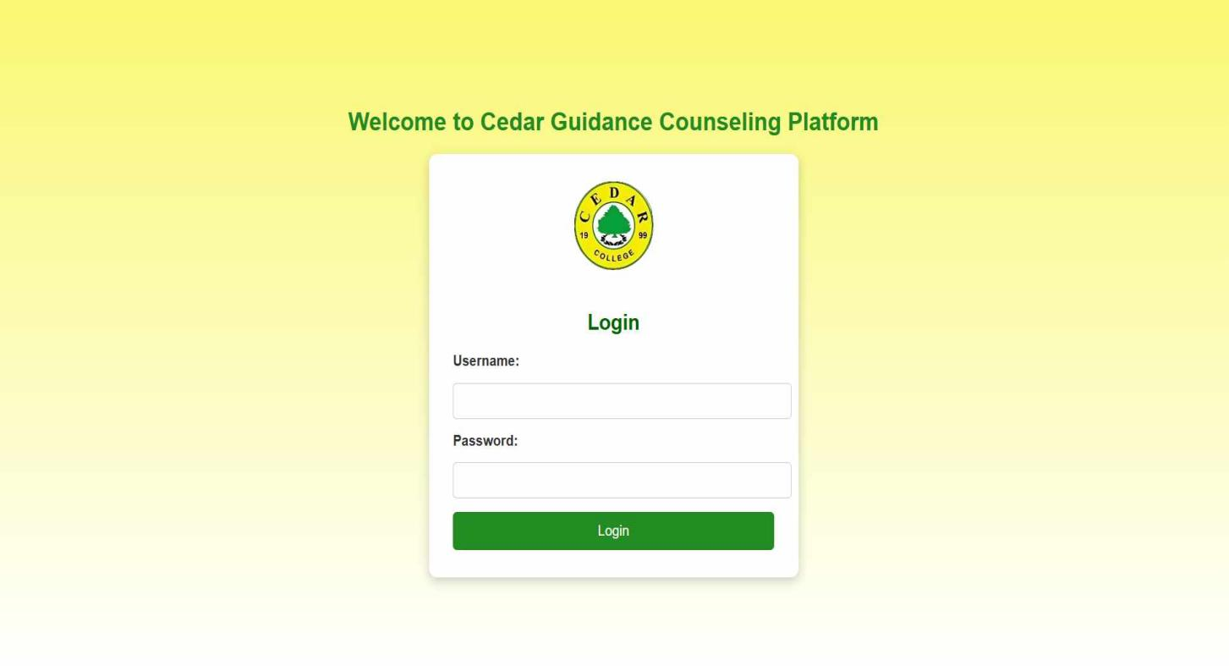

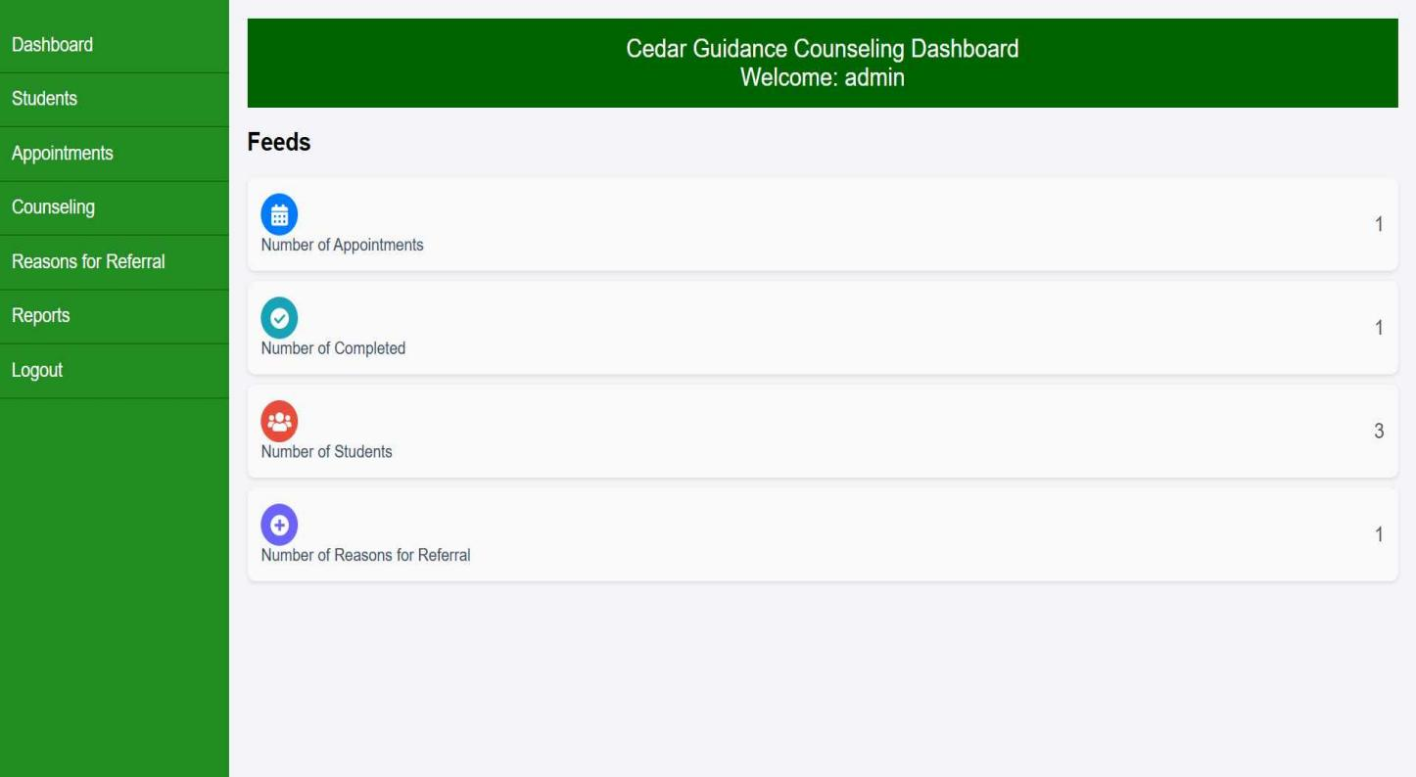

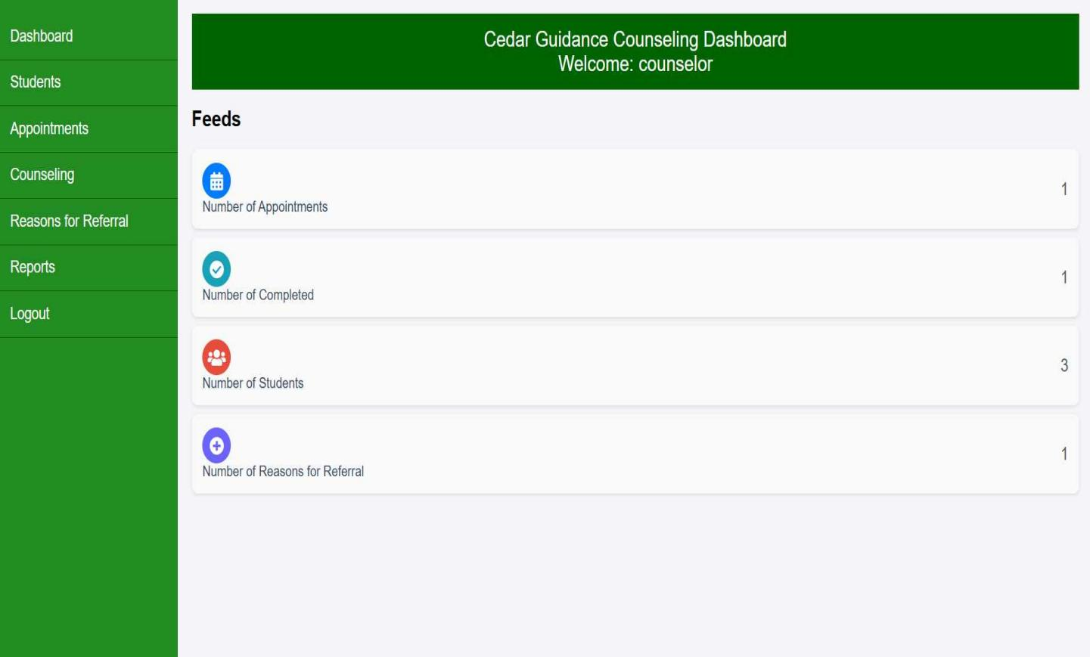

**Data Flow Diagram**

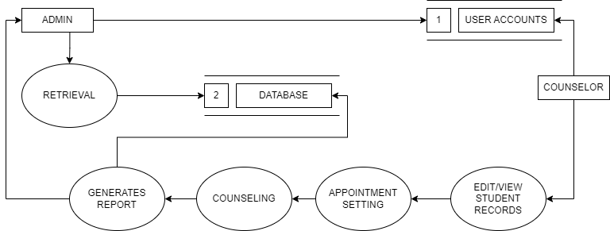

**Data Flow Diagram – Level 0**

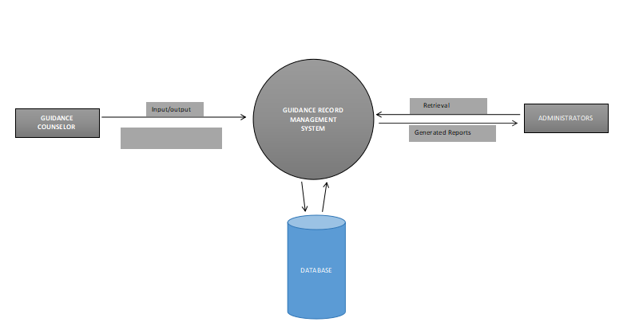

ER Diagram

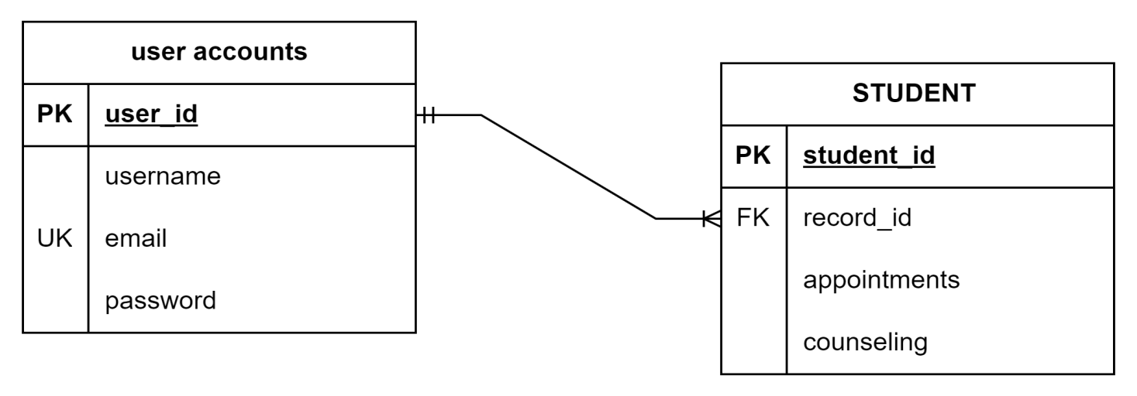

**System Architecture**

Layered architecture is used in the "Web-Based Computerized Guidance Records Management System" to keep the system organized and easier to maintain. By dividing tasks into distinct layers, such as user interface, business logic, and data management, the system ensures that updates or changes in one layer do not affect the others. This separation improves flexibility for future enhancements, scalability to handle more users and data, and security by isolating sensitive data handling in specific layers.

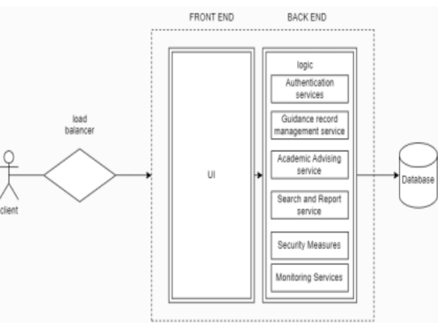

**PERT  
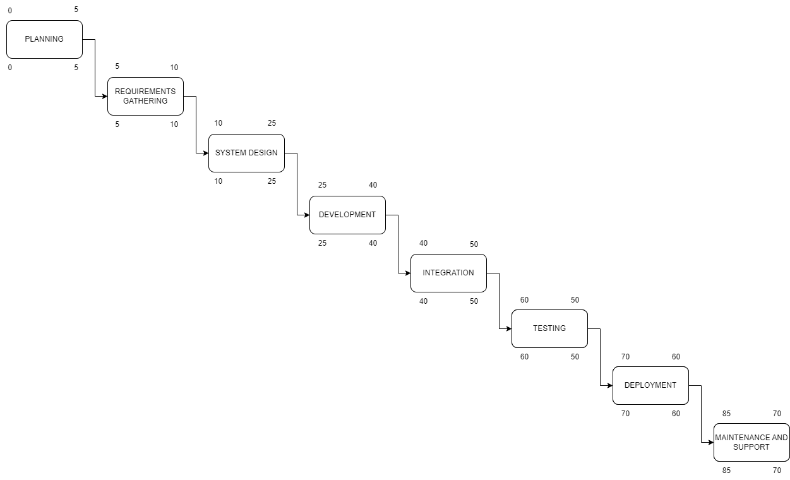**

CPM

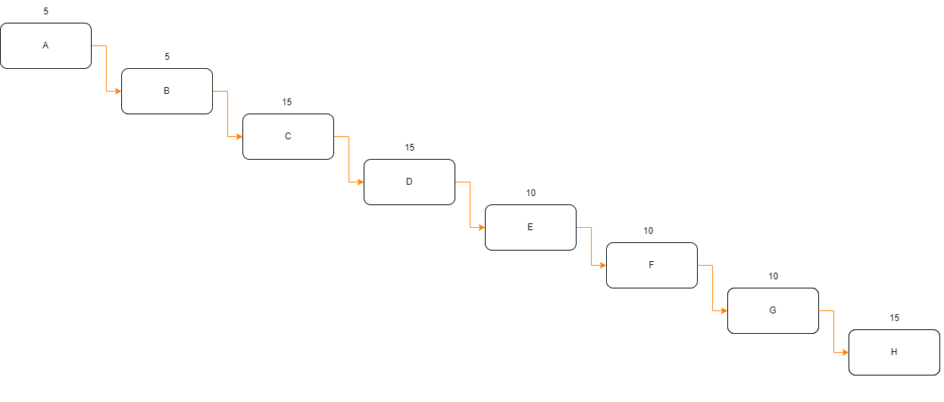

* **Planning = 5 days**
* **Requirements Gathering = 5 days**
* **System Design = 15 days**
* **Development = 15 days**
* **Integration = 10 days**
* **Testing = 10 days**
* **Deployment = 10 days**
* **Maintenance and Support = 15 days**

**TOTAL DURATION OF PATH:**

**5 + 5 + 15 + 15 + 10 + 10 + 10 + 10 = 85 days**

**CHAPTER III**

**FINDINGS AND PROJECTIONS**

A survey was conducted as part of the requirements gathering phase for developing the Web-Based Computerized Guidance Records Management System, which aims to streamline the management of student guidance records and provide tailored resources to enhance support services.

The survey was distributed to 15 respondents, consisting of 7 males (46.67%) and 8 females (53.33%).

The questions were based on the ISO/IEC 25010 standard, and responses were collected using a Likert scale with options ranging from Strongly Agree,Agree,Neutral,Disagree,Strongly Disagree.

**Findings**

**Figure 1. Survey Responses on The system should be easy to access.**

As shown in the survey, 20% of users strongly agree, 67% agree, and 13% are neutral. The vast majority find the system easy to access, although a small percentage (13%) remains uncertain.

**Figure 2. Survey Responses on Managing student records should be simple.**

As shown, 20% strongly agree, 53% agree, and 27% are neutral. Most users find managing records simple, but a notable 27% are uncertain, possibly indicating room for improvement in the user interface or process.

**Figure 3.** **Survey Responses on Scheduling guidance appointments should be straightforward.**

As shown, 20% strongly agree, 53% agree, and 27% are neutral. While most users find scheduling easy, 27% feel it could be improved. This suggests that some users might find the process less intuitive.

**Figure 4.** Survey Responses on Sending automated email notifications to students should be reliable.

As shown, 13% strongly agree, 47% agree, and 40% are neutral. Although most users believe the system saves time, 40% remain unsure, suggesting that time-saving benefits are not fully realized by some.

**Figure 5.** **Survey Responses on The system should reduce time spent on manual task.**

As shown, 13% strongly agree, 40% agree, and 47% are neutral. While 53% find the email notifications reliable, a large portion (47%) is unsure. This could indicate concerns about the consistency or clarity of notifications.

**Figure 6.** **Survey Responses on** **The system should reduce effort spent on manual task**

As shown, 20% strongly agree, 53% agree, and 27% are neutral. The majority agree that the system reduces manual effort, but the 27% neutral responses suggest some users may not see a significant difference.

**Figure 7. Survey Responses on The system should allow easy retrieval of student records.**

As shown, 33% strongly agree, 40% agree, and 27% are neutral. Most users find retrieving records easy, though 27% are unsure, possibly due to issues with search or filtering functions.

**Figure 8. Survey Responses on The email notification feature should clearly communicate appointment details to student**

As shown, 33% strongly agree, 47% agree, and 20% are neutral. The majority believe the email notifications clearly communicate appointment details, but the 20% neutral responses suggest there might be some areas for improvement.

**Figure 9.** **Survey Responses on The system should be convenient in scheduling for students.**

As shown, 20% strongly agree, 67% agree, and 13% are neutral. Most users find the system convenient for scheduling, though the 13% neutral responses suggest some users might experience minor inconveniences.

**Figure 10.** **Survey Responses on The system should provide comprehensive reports on guidance records.**

As shown, 20% strongly agree, 67% agree, and 13% are neutral. Most users agree that the reporting feature is comprehensive, but 13% remain unsure, possibly due to a lack of customization or clarity in the reports.

**Figure 11.** **Survey Responses on The system should allow seamless communication between students and the guidance office.**

As shown, 27% strongly agree, 40% agree, and 33% are neutral. Many users agree that communication is seamless, but the 33% neutral responses suggest there might be some difficulties or inefficiencies in the communication process.

**Figure 12.** **Survey Responses on The system should be enhance the overall efficiency of guidance operations.**

As shown, 33% strongly agree, 47% agree, and 20% are neutral. While most users agree that the system enhances efficiency, 20% are neutral, suggesting that there may still be some operational bottlenecks.

**Figure 13.** **Survey Responses on The system should ensure that guidance records remain confidential.**

As shown, 53% strongly agree, 40% agree, and 7% are neutral. A large majority believe that guidance records are kept confidential, with only a small percentage unsure about security measures.

**Figure 14.** **Survey Responses on Only authorized users (counselors and administrators) should be able to access the system**

As shown, 40% strongly agree, 40% agree, and 20% are neutral. Most users agree that only authorized personnel should have access, but the 20% neutral responses could indicate confusion about access roles or permissions.

**Figure 15.** **Survey Responses The system should include features to protect sensitive student information from unauthorized access.**

As shown, 60% strongly agree, 20% agree, and 20% are neutral. A significant majority believe the system protects sensitive information, although the 20% neutral responses suggest some concerns or lack of awareness about the security measures in place.

**CHAPTER 4**

**CONCLUSION AND RECOMMENDATIONS**